Title

Yoshihiko Ihara¹, Hideaki Obuse^{2,1}, and Yukitoshi Motome

¹ Department of Physics, Hokkaido University, Japan
²Department of Applied Physics, Hokkaido University, Japan
³ Department of Applied Physics, The University of Tokyo, Japan

Email: nfam@eng.hokudai.ac.jp

This is the Microsoft Word template file for an abstract for NFAM.

The preferred format is:
- Total length: 1 page
- Title: Times New Roman Bold, 18pt
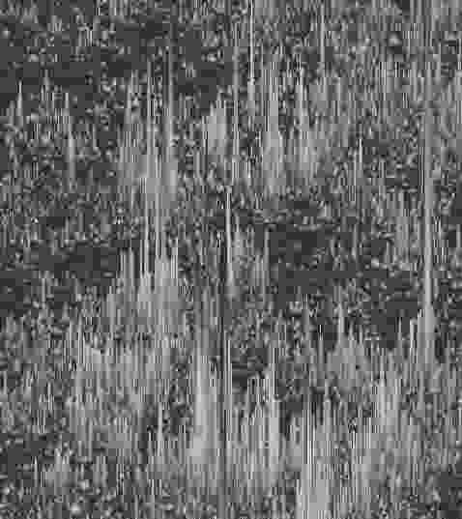
Fig.1: The figure caption.
- Authors: Times New Roman, 14pt
- Affiliations: Times New Roman Italic, 12pt
- Email: Times New Roman, 11pt
- Main text and references: Times New Roman, 12pt
- Figure caption: Times New Roman, 11pt

Please convert this file to PDF before submission. The file name should be {First name}-{Family name} of the author who gives the presentation followed by either “_Talk.pdf” or “_Poster.pdf”, depending on the type of presentation, e.g. Hideki-Hirori_Talk.pdf or Satoru-Hayami_Poster.pdf. The email address given after the list of affiliations should be that of the presenter.

[1] P. Anderson, Phys. Rev. 109, 1492 (1958).

For those who have a Google account,
- please submit your abstract through the form here.
For those who cannot use the Google services,
- please send the filled form and the PDF of your abstract to nfam@eng.hokudai.ac.jp by the deadline. The subject of the email should be "Abstract".In the body, please provide the following information:
-------------------------
Email address*:
First name*:
Middle name:
Last Name*:
Title*: Prof./ Dr./ Ms./ Mr.
Affiliation*:
Country of the affiliation*:
Type of presentation you prefer*: Talk/Poster
Title of your presentation*:
(*:required)
-------------------------

